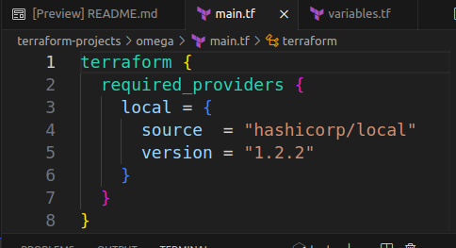
LAB 14: Versioin Constraints

Q-1
Navigate to the directory /root/terraform-projects/omega where we have added a configuration file. Inspect the file and choose the correct version of the provider from the below options:
A-1 version = 1.2.2

Q-2
Now, change to the directory /root/terraform-projects/rotate. We have already initialized the configuration directory using the terraform init command.
Inspect the rotation.tf file and find out the correct version of the provider plugin that is downloaded.
Choose the correct version from the below options:
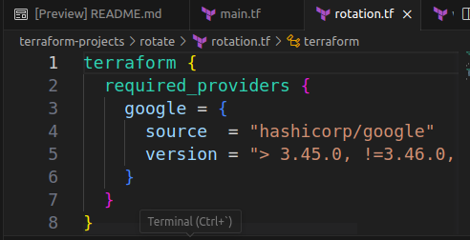
You don't have to create the resources!!
A-2 3.47.0
versions = 3.45.0,
bcz, != 3.46.0 means greater theb 3.45.0 but don’t use 3.45.9

Q-3
Which one of the below is not a valid version constraint operator ?
A-3 a. ~> b. == c. <= d. >= e. !=
A-3 b.==

Q-4
We have been working on a project called nautilus under the configuration directory /root/terraform-projects/nautilus.
Due to a version mismatch, we don't want to download the aws provider version 3.17.0. Which version constraint can be used to achieve this?
You can try to add the below options in nautilus.tf to verify the correct syntax.
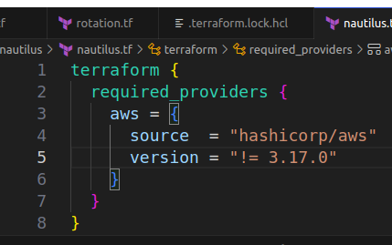
A-4 versaion = “!= 3.17.0”

Q-5
Now, navigate to the directory /root/terraform-projects/lexicorp where we have added the configuration files. Inspect the file and find out which version of providers will be download.
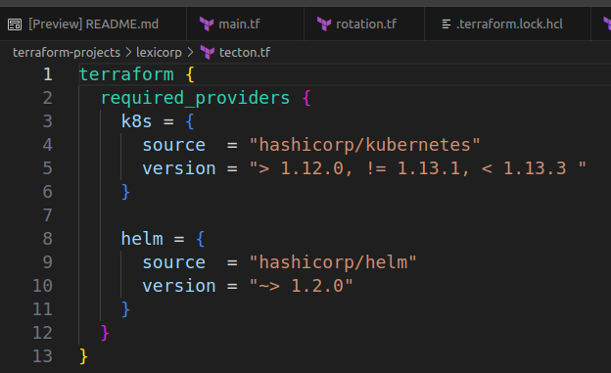
If unsure, refer to the documentation. Documentation tab is available at the top right panel.
A-5
terraform init
so, terraform will download and installs specific versions ,

A-5
kubernetes v1.13.2 & helm v1.2.4

cd terraform-projects/lexicorp/

root in ~/terraform-projects/lexicorp via 💠 default on ☁️ (us-east-1)
❯ terraform init

Initializing the backend...

Initializing provider plugins...
- Finding hashicorp/kubernetes versions matching "> 1.12.0, != 1.13.1, < 1.13.3"...
- Finding hashicorp/helm versions matching "~> 1.2.0"...
- Installing hashicorp/kubernetes v1.13.2...
- Installed hashicorp/kubernetes v1.13.2 (signed by HashiCorp)
- Installing hashicorp/helm v1.2.4...
- Installed hashicorp/helm v1.2.4 (signed by HashiCorp)

Terraform has created a lock file .terraform.lock.hcl to record the provider
selections it made above. Include this file in your version control repository
so that Terraform can guarantee to make the same selections by default when
you run "terraform init" in the future.

Terraform has been successfully initialized!

You may now begin working with Terraform. Try running "terraform plan" to see
any changes that are required for your infrastructure. All Terraform commands
should now work.

If you ever set or change modules or backend configuration for Terraform,
rerun this command to reinitialize your working directory. If you forget, other
commands will detect it and remind you to do so if necessary.

